FASHION MARKET RESEARCH
Task 6 - Presentation and Reporting
Comprehensive Report

Name: Ruchira Y.Kudke
Internship: YuvaIntern – Junior Data Analyst - Apparel, Textiles & Fashion
Project Area: Fashion Market Research, Data Analytics & Predictive Modelling
Final Task: Week 6- Presentation and Reporting
Tools Used: Python, Pandas, NumPy, Matplotlib, PowerBI, Scikit-learn

Prepared by Ruchira Y. Kudke

Table of Content
1. Executive Summary
2. Introduction
3. Data Collection and Research Methodology
4. Data Cleaning and Pre-processing
5. Data Analysis and Interpretation
6. Power BI Dashboard and Visualization
7. Predictive Modelling
8. Strategic Recommendations
9. Integrated Findings and Business Implications
10. Limitations
11. Conclusion
12. References and Sources

- Executive Summary
This final report consolidates the work completed across the fashion market research tasks. The analysis focused on five global fashion brands—Nike, Chanel, Louis Vuitton, Zara and Gucci— and examined product characteristics, pricing, sustainability, customer ratings, reviews, stock levels, market segments and other product-related attributes. The initial research used publicly available information including official brand websites, public databases, and social media accounts.
Observed prices were treated as indicative because fashion prices vary by category, collection, season, availability and promotions.

The data-cleaning stage addressed missing values, inconsistent records, data-types issues, date formatting, invalid numeric values and duplicate identifiers. The original Task 2 submission did not contain the complete brand Coverage because Zara records were omitted. This was identified and corrected before Task 3, when the dataset was updated to 173 product records and 19 variables. Therefore, all Power BI analysis, predictive modelling and strategic recommendations in this final report use the updated 173 record dataset.

The Power BI analysis of the 173-product dataset reported an overall average price of approximately ₹75K, average rating of 4.5/5, approximately 32K total reviews and an average sustainability score of 4.9. Chanel had the highest average price at approximately ₹165K, followed by Louis Vuitton at ₹156K and Gucci at ₹112K. Nike and Zara had lower average prices of approximately ₹8K and ₹4K respectively. Luxury Fashion represented 83 products (47.98%), Accessories was the largest category by product count, and Apparel generated the highest review-based engagement.

Predictive modelling used Price_INR as the target variable. Linear Regression was developed as a baseline and Random Forest Regression was used to capture non-linear relationships. On the 35-record test set, Random Forest reported MAE of ₹26,564.31, RMSE of ₹56,975.68 and R² of 0.7425. Stock_Units was the most influential feature in the trained model,followed by Ratings. These feature-importance values indicate usefulness for prediction, not causal effects.
The final strategic recommendations cover product development, pricing, target demographics, inventory management and sustainability. Together, the tasks demonstrate a complete analytics workflow: collecting market information, preparing data, analysing patterns, building a predictive model and translating the findings into practical guidelines for a hypothetical fashion brand.

- Introduction
The week 6 task brings together the findings from previous fashion market research activities into a single structured report. The overall work was designed to examine differences across selected fashion brands and to demonstrate how descriptive analytics, visualization and predictive modelling can support data-informed business planning.

Objectives
- Study the market positioning and product characteristics of five selected global fashion brands.
- Collect and organize information about products, pricing, sustainability, availability, ratings, reviews, stock and market segments.
- Clean and standardize the collected dataset for analysis.
- Use Power BI to identify pricing, product-mix, customer-engagement and sustainability patterns.
- Develop regression models to estimate fashion product prices.
- Evaluate model performance using MAE, RMSE and R².
- Translate analytical and modelling findings into strategic recommendations for a hypothetical fashion brand.

- Data Collection and Research Methodology
The research covered Nike, Chanel, Louis Vuitton, Zara and Gucci. The selected brands represent different positions within the fashion industry, including sportswear, luxury fashion and fast fashion/high street. The research used publicly available information from official brand websites, corporate reports/public databases and official social-media accounts.

Brand | Segment | Indicative observed price range in India
Nike | Sportswear / Athleisure | ₹7,500–₹15,000+ for selected footwear
Chanel | Luxury Fashion | Beauty ~₹5,000+; RTW ~₹1,00,000+; handbags ~₹4,00,000+
Louis Vuitton | Luxury Fashion | Small leather goods ~₹30,000+; selected handbags ~₹1,80,000–₹6,00,000+
Gucci | Luxury Fashion | Accessories ~₹30,000+; handbags ~₹1,00,000–₹4,00,000+
Zara | Fast Fashion / High Street | Approximately ₹1,500–₹15,000+ depending on category

The Week 1 report notes that prices were observed from selected products on Indian brand websites and are not fixed market-wide averages.
Prices can vary by product category, collection, season, country, availability and promotions. The research was done on 18 August 2026.

Product and Market Variables
- Brand and product category/sub-category
- Product name and product identifiers
- Price in Indian Rupees (Price_INR)
- Availability and store type
- Target age group and market segment
- Country of origin
- Sustainability score
- Stock units
- Ratings and review count
- Date added and product variants

Social-Media Research
Official Instagram accounts were reviewed to understand the type of content and consumer positioning used by the selected brands. Nike emphasized athletes, sports campaigns, footwear launches, performance and lifestyle content. Chanel focused on luxury fashion, beauty, runway collections, heritage and creative campaigns. Louis Vuitton emphasized handbags, collections, travel heritage, art and cultural collaborations. Gucci featured luxury fashion, footwear, accessories and creative/cultural campaigns, while Zara emphasized seasonal collections, trend-led fashion, styling and new arrivals.

- Data Cleaning and Pre-processing
Dataset update: The Task 2 submission did not include Zara records, so it did not represent the complete dataset. After this was identified, the dataset was updated before Task 3. The updated dataset contains 173 product records and 19 variables, and this version is used throughout the final analysis, predictive modelling and recommendations.
The data-cleaning task was performed to identify and handle missing values, inconsistent records, duplicate records, incorrect data types and formatting issues so that the dataset could be used for further analysis and predictive modelling.

Problems Identified
- Missing values were identified in Reviews_Count in the raw dataset.
- Some records contained values in incorrect columns, particularly among a small number of beauty-product records.
- Ratings contained non-rating values such as colour names in affected records.
- Stock_Units contained values belonging to size or colour fields in affected records.
- Date_Added required standardization to a consistent date format.
- A repeated SKU was identified for different products.
- Several numeric columns required conversion from mixed or inconsistent data types.
- Numeric values were checked for invalid ranges and negative values.

Cleaning Steps
- Removed leading and trailing spaces from text and categorical fields.
- Converted Date_Added from DD-MM-YYYY to YYYY-MM-DD.
- Converted Price_INR, Sustainability_Score, Stock_Units, Ratings and Reviews_Count to numeric data types.
- Corrected affected records by placing size, colour, quantity and rating information in the appropriate fields.
- Validated Ratings against the 1–5 range and Sustainability_Score against the 0–10 range.
- Handled missing numeric values using median imputation within Sub_Category, with the overall median as fallback.
- Checked complete duplicate rows and duplicate SKU identifiers; distinct products were retained.
- Used boxplots for outlier checking and applied appropriate final numeric formatting.

Validation item | Task 2 reported result
Final analytical dataset records | 173 (updated dataset used from Task 3 onward)
Columns | 19
Complete duplicate rows | 0
Duplicate SKUs | 0
Missing values | Task 2 validation table reports 4; narrative states missing/invalid values were handled
Negative prices | 0
Negative stock values | 0
Negative review counts | 0

The original Task 2 submission had incomplete brand coverage because Zara records were omitted. Once this was identified, the dataset was updated before Task 3. The final 173-record dataset is therefore the basis for the Power BI analysis, predictive modelling and strategic recommendations presented in this report.
The Task 2 report states that the cleaning process improved quality, consistency and usability. It also records that distinct products were not unnecessarily deleted when a repeated identifier was encountered.

- Data Analysis and Interpretation
Task 3 used the cleaned & updated dataset and Power BI to examine pricing, sustainability, customer ratings, product distribution, product representation and review-based customer engagement. The dashboard was designed with filters for Brand, Segment and Product Category.

KPI | Reported value
Total Products | 173
Average Price | Approximately ₹75K
Average Rating | 4.5 / 5
Total Reviews | 32K
Average Sustainability Score | 4.9

Pricing Analysis

Brand | Average price | Reported positioning in dataset
Chanel | ₹165K | Luxury / highest price
Louis Vuitton | ₹156K | Luxury / very high price
Gucci | ₹112K | Premium / luxury
Nike | ₹8K | Accessible sportswear
Zara | ₹4K | Accessible mass fashion

The dashboard shows a clear difference between the average price levels of the luxury/premium brands and the lower average price levels reported for Nike and Zara in the analysed dataset.

Sustainability Analysis
Brand | Average sustainability score
Nike | 6.5
Zara | 6.5
Chanel | 3.7
Gucci | 3.0
Louis Vuitton | 3.0

Nike and Zara recorded the highest average sustainability scores in the analysed dataset at 6.5 each. The Task 3 report says that the “highest-priced brands did not have the highest average sustainability scores in this dataset”.
Customer Ratings and Price–Rating Relationship
- Overall average rating: 4.5/5.
- Chanel: 4.6 average rating.
- Gucci, Louis Vuitton and Zara: 4.5 average rating each.
- Nike: 4.4 average rating.
- The difference between the highest and lowest reported brand average rating is 0.2 points.
- The analysis reported that higher average price did not automatically correspond to a higher customer rating in this dataset.

Segment | Products | Share
Luxury Fashion | 83 | 47.98%
Mass Fashion | 60 | 34.68%
Sportswear | 30 | 17.34%

Category | Approx. product count | Observation
Accessories | 79 | Most represented
Apparel | 58 | Second-largest
Footwear | 22–23 | Smaller presence
Beauty | 14 | Smallest presence

Luxury Fashion was the largest segment in the analysed sample & Accessories was the largest category by product count. The Task 3 report also cautions that product representation reflects the composition of the selected dataset rather than exact real-world market share.

Customer Engagement
Category | Total review volume reported
Apparel | 12.5K
Accessories | 11.3K
Footwear | 4.5K
Beauty | 4.1K

Apparel generated the highest review-based customer engagement, even though Accessories had the largest number of products. This shows that product count and review volume are different measures and should not be treated as identical indicators.

Power BI Dashboard
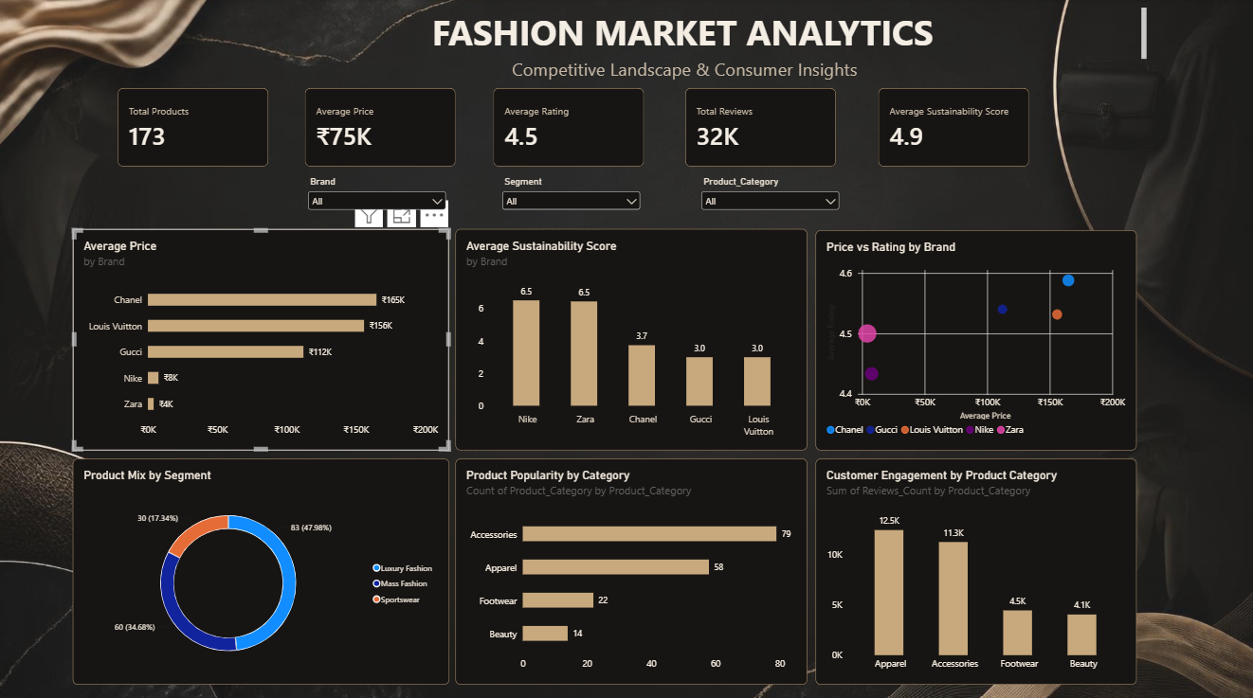

- Power BI Dashboard and Visualization
The Power BI dashboard converted the prepared dataset into an interactive market-analysis view. The dashboard included KPI cards and visuals charts for brand pricing, sustainability, price vs rating, segment composition, category representation and customer engagement.

- KPI Cards – Total Products, Average Price, Average Rating, Total Reviews and Average Sustainability Score.
- Average Price by Brand – comparison of pricing levels.
- Average Sustainability Score by Brand – sustainability comparison.
- Price vs Rating by Brand – relationship between price and customer rating.
- Product Mix by Segment – segment composition.
- Product Popularity by Category – product count by category.
- Customer Engagement by Product Category – total review volume by category.
Key Analytical Findings
- Chanel had the highest reported average price, while Zara had the lowest.
- Nike and Zara had the highest reported average sustainability scores in the dataset.
- Luxury Fashion was the largest segment in the analysed sample.
- Accessories was the most represented category by product count.
- Apparel generated the highest review-based customer engagement.
- Ratings remained relatively high across all five brands despite large differences in average price.

- Predictive Modelling
Task 4 applied regression modelling to estimate fashion product prices. Prices_INR was selected as the target variable.
The Predictive modelling dataset contained 173 records and 19 variables, with 12 selected input features.

Selected Features
- Brand
- Product_Category
- Sub_Category
- Availability
- Target_Age_Group
- Segment
- Country_Origin
- Sustainability_Score
- Store_Type
- Stock_Units
- Ratings
- Reviews_Count
Product_Name, Currency, SKU, Date_Added, Size_Variants and Color_Variants were excluded from the selected input set for the stated modelling objective. Price_INR was excluded from the inputs because it was the target variable.

Model Development
- Linear Regression was used as the baseline model.
- Random Forest Regression was used to capture non-linear relationships and interactions.
- Categorical variables were converted using One-Hot Encoding.
- 80% of the data (138 records) was used for training and 20% (35 records) for testing.
- Random Forest was configured with 200 trees (n_estimators=200) and random_state=42.
- Both models used the same training and testing split for comparison.

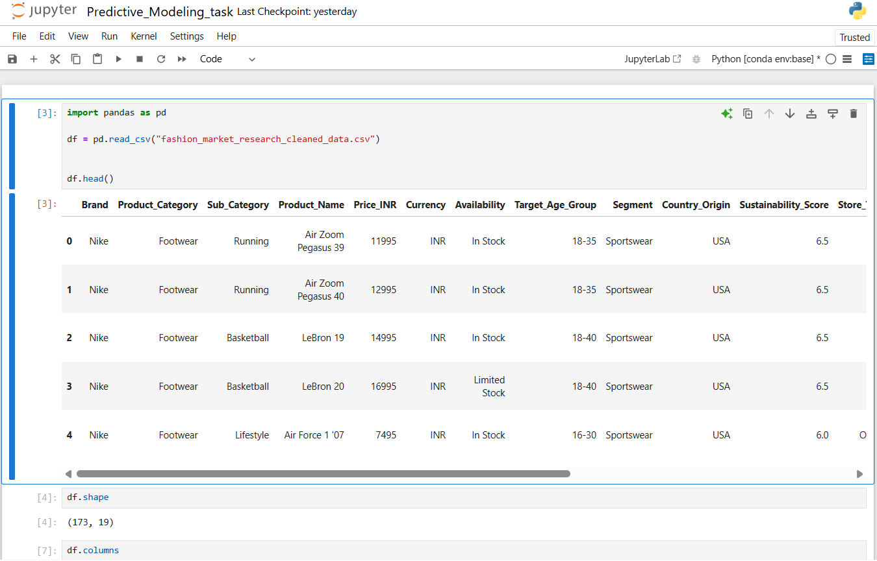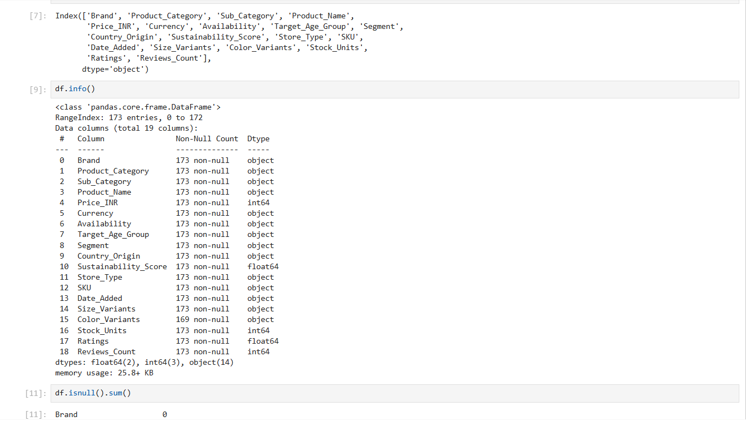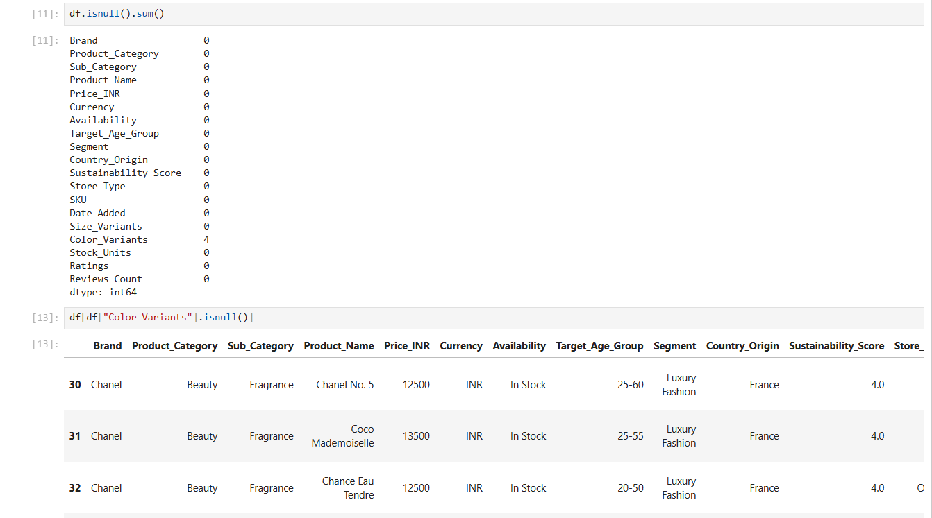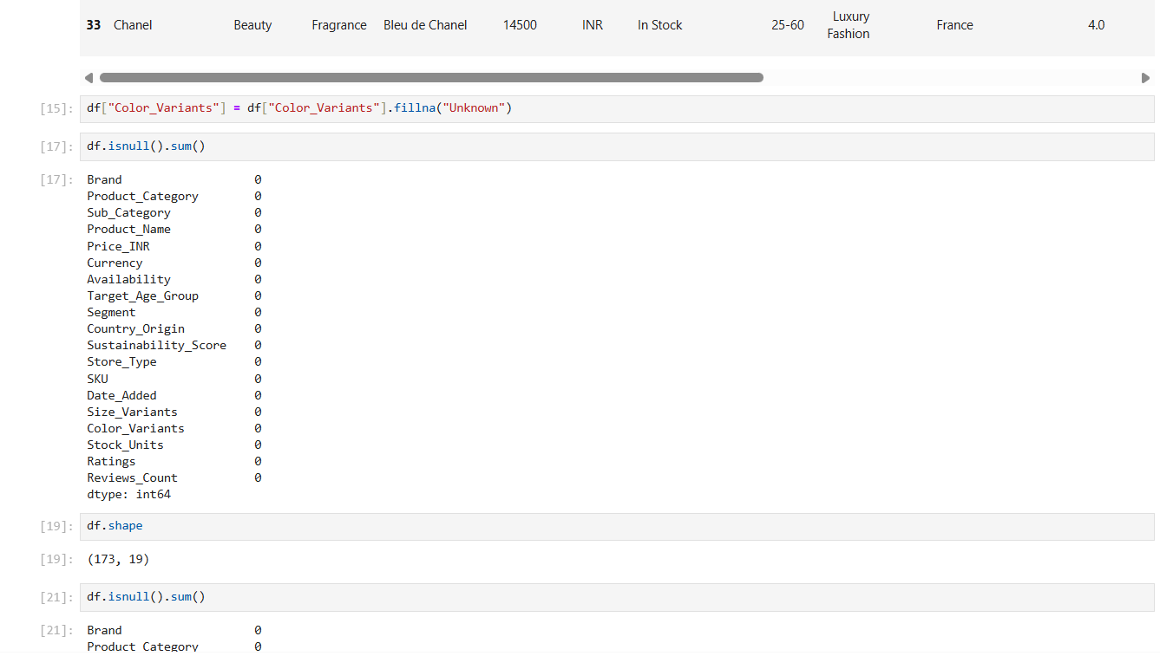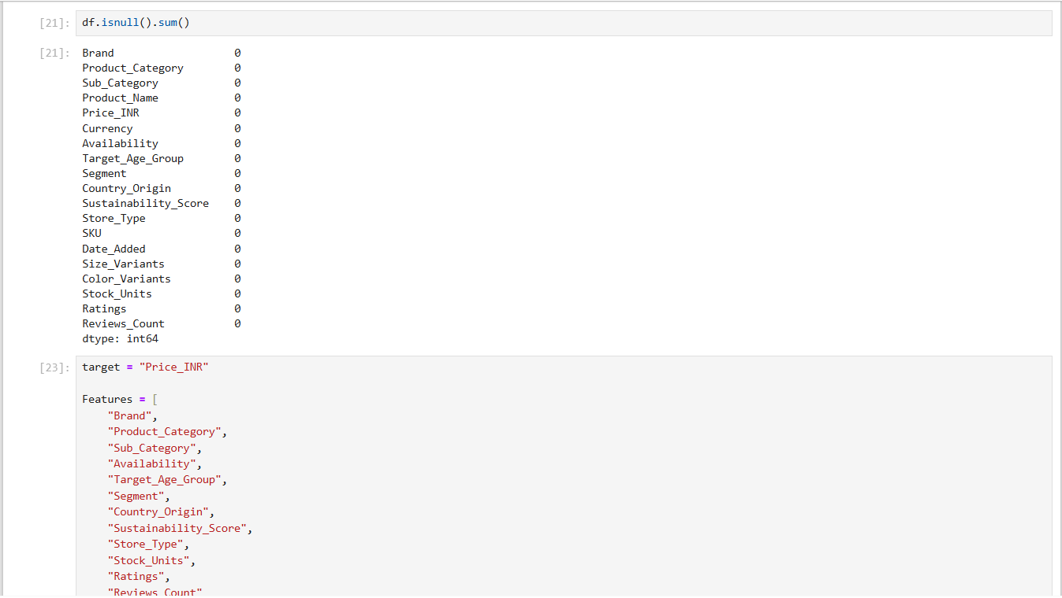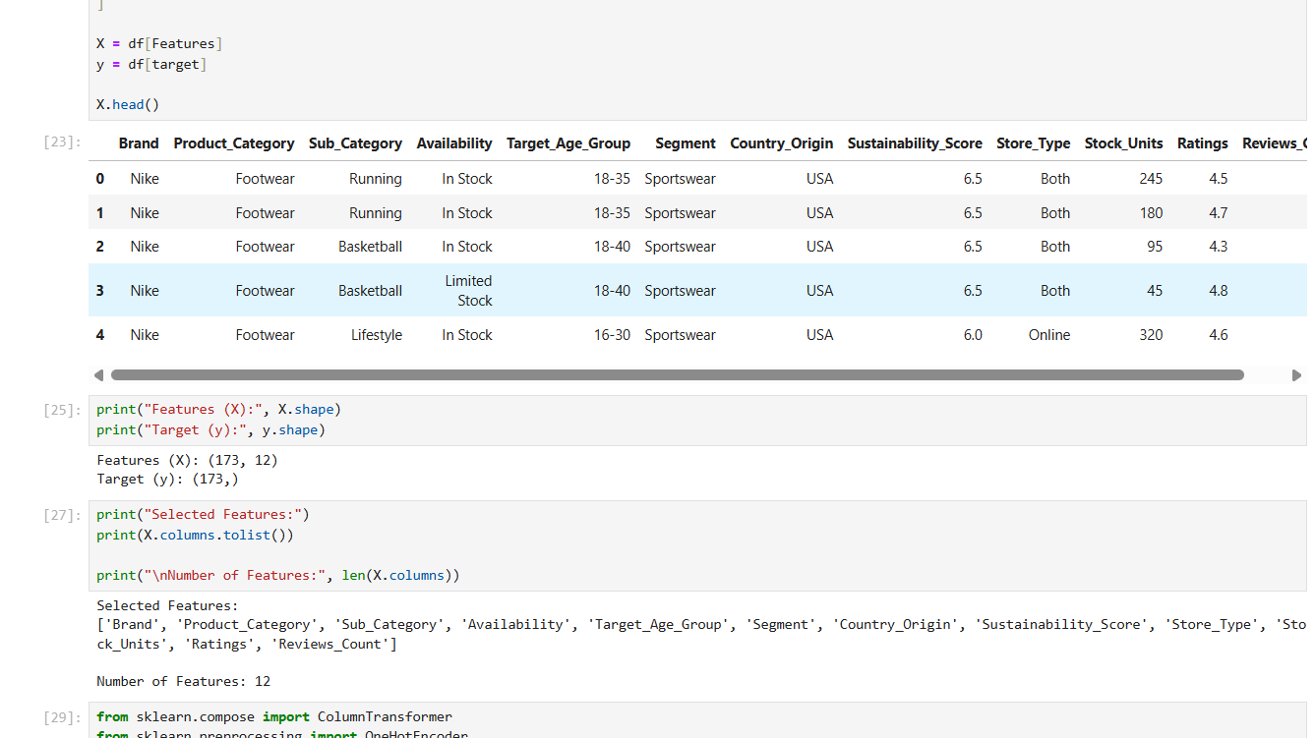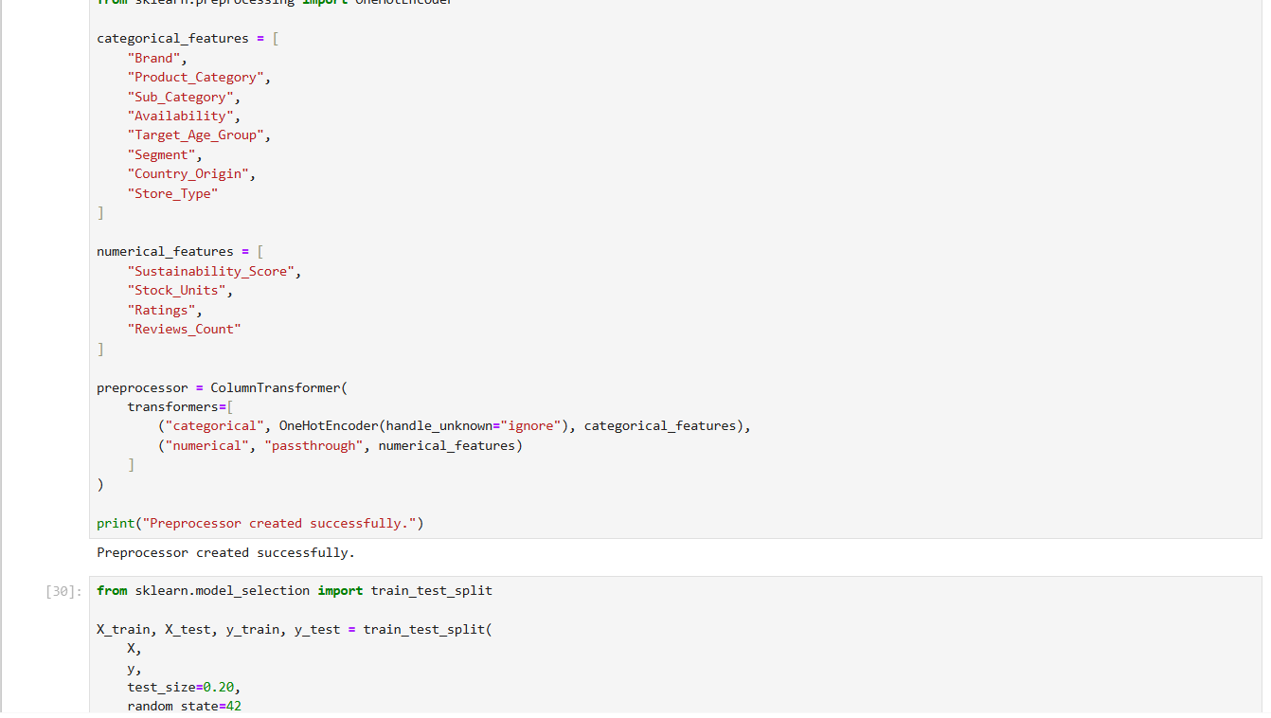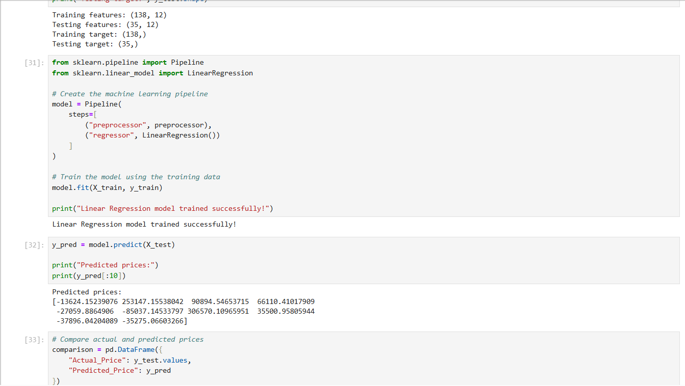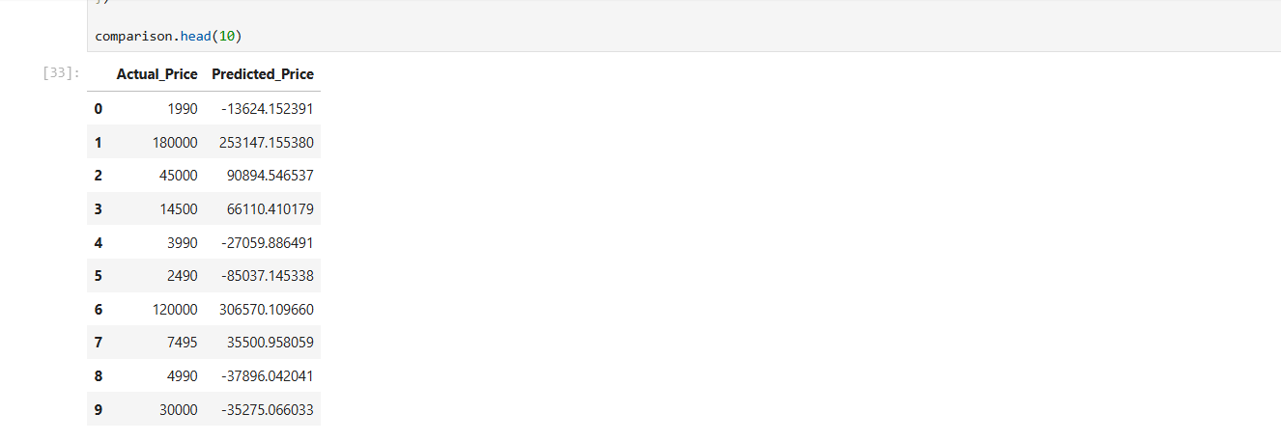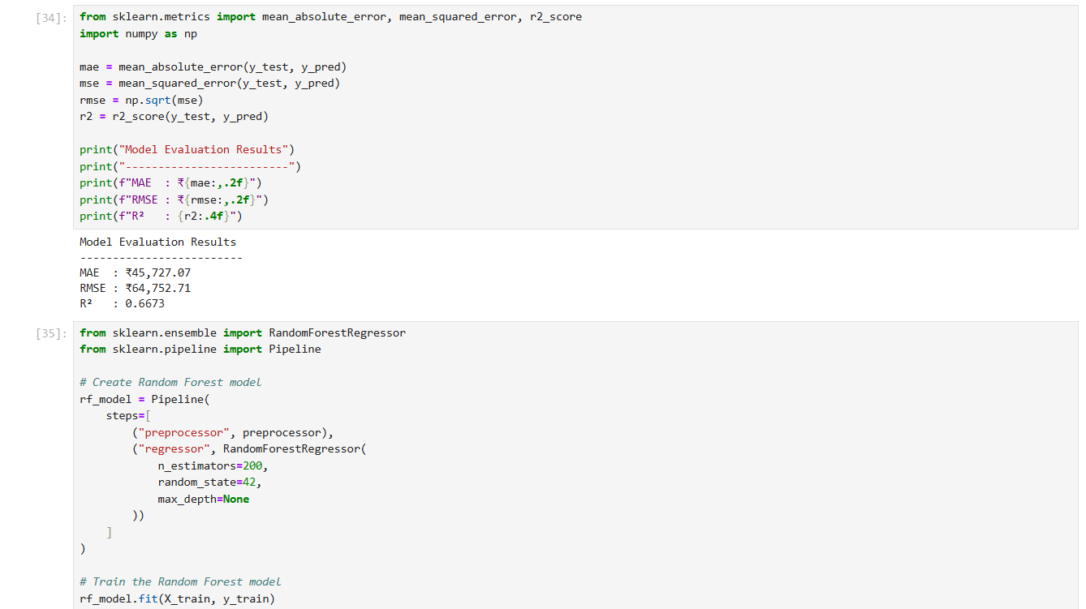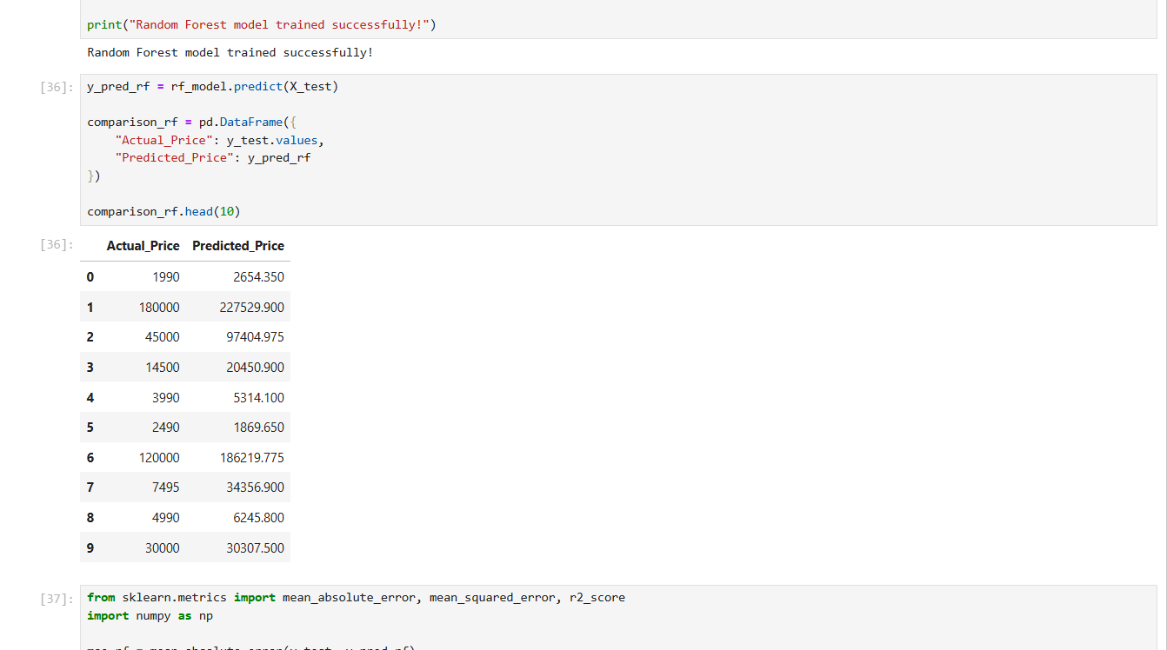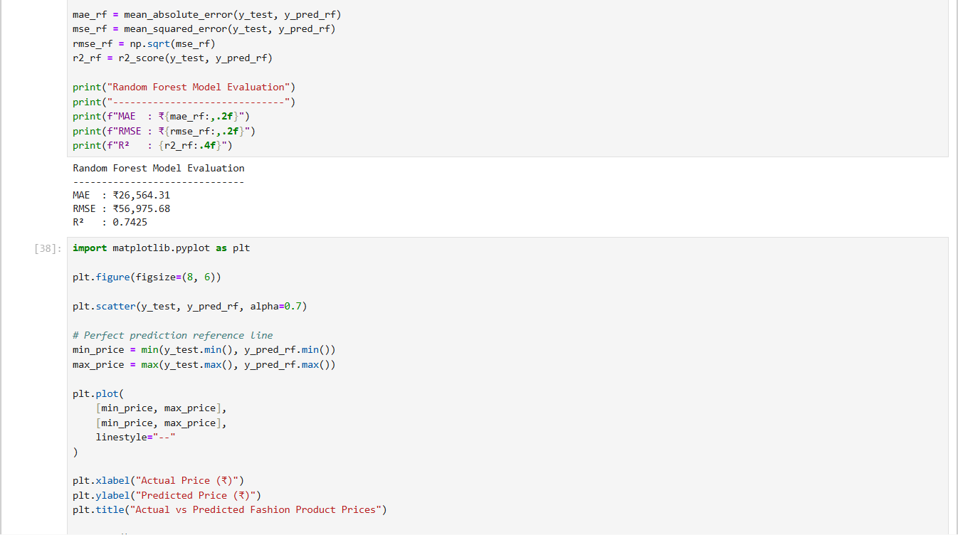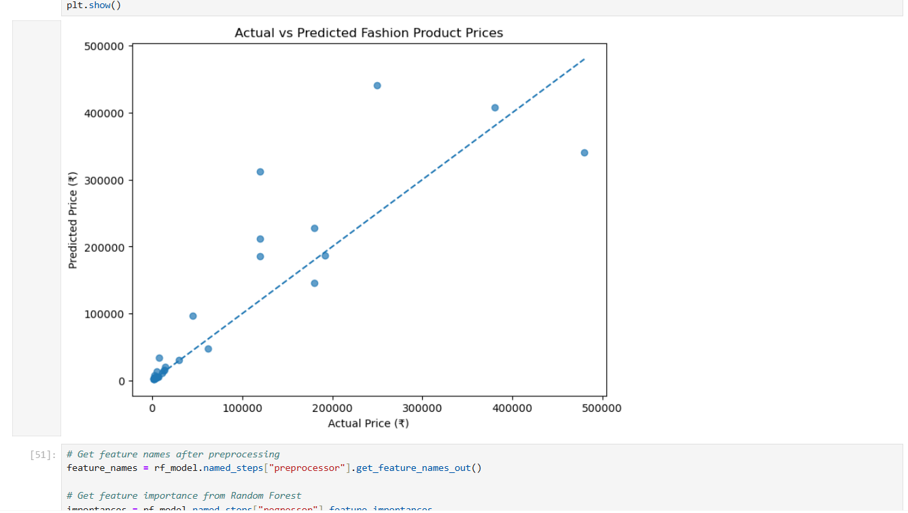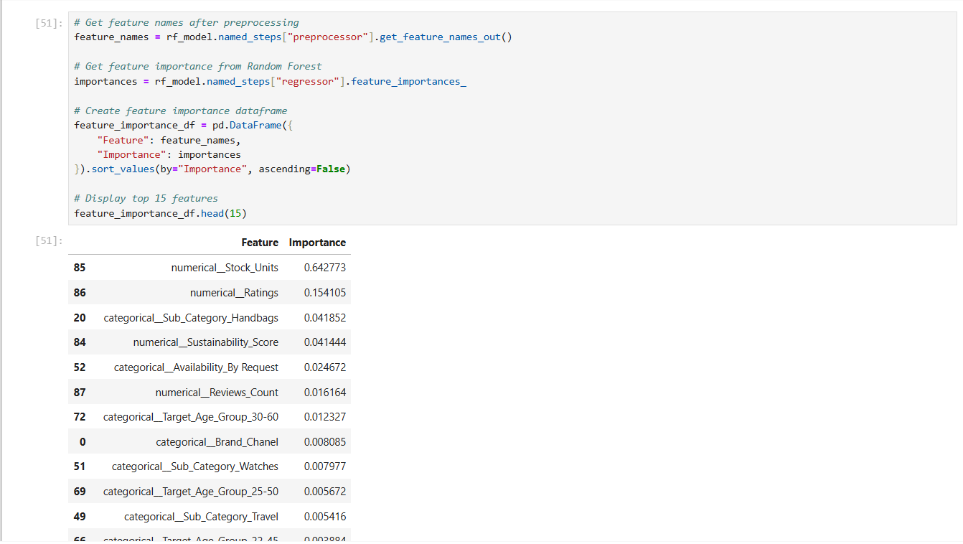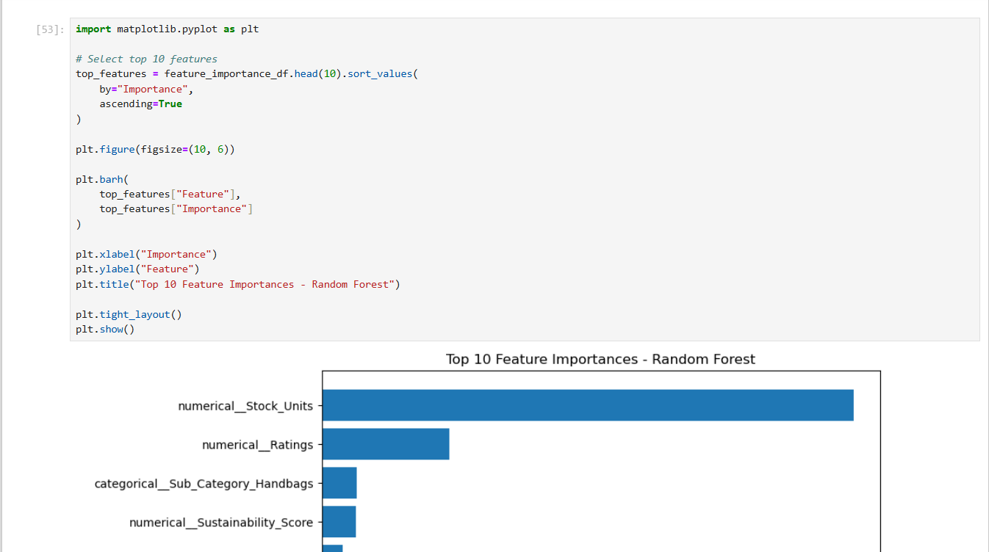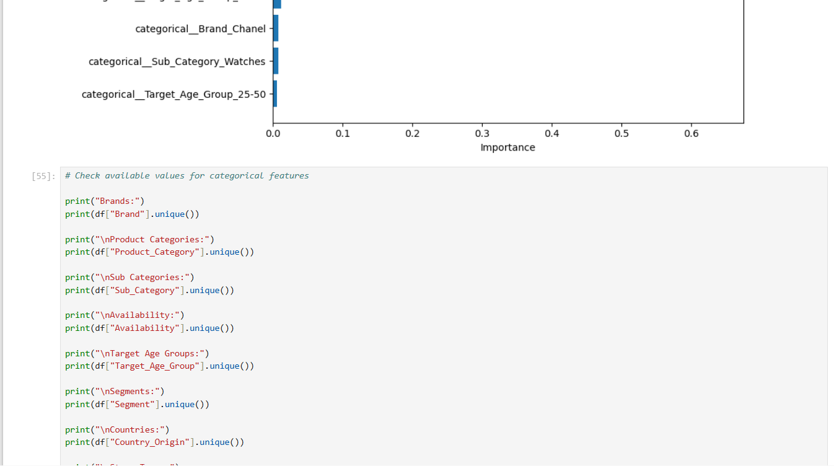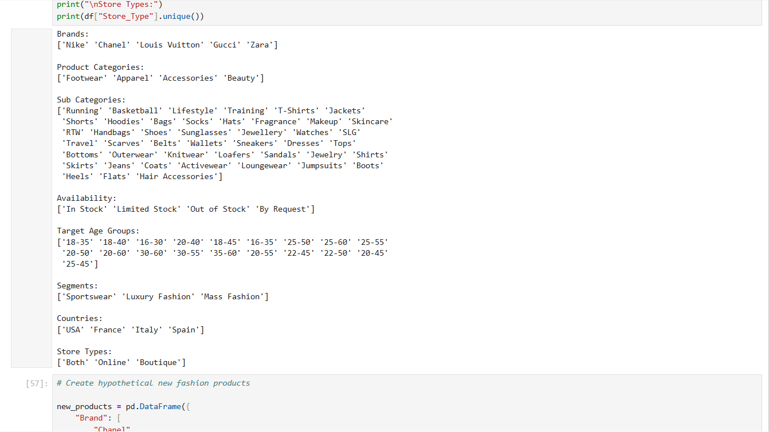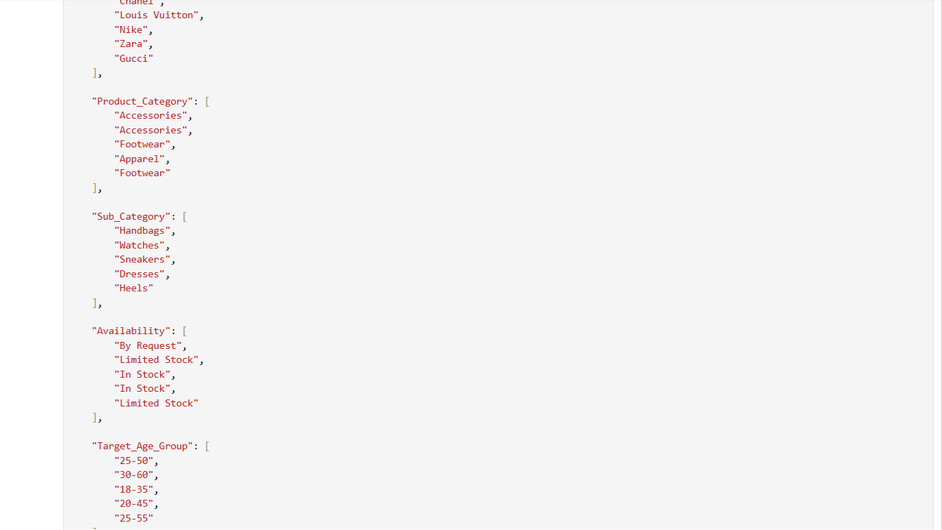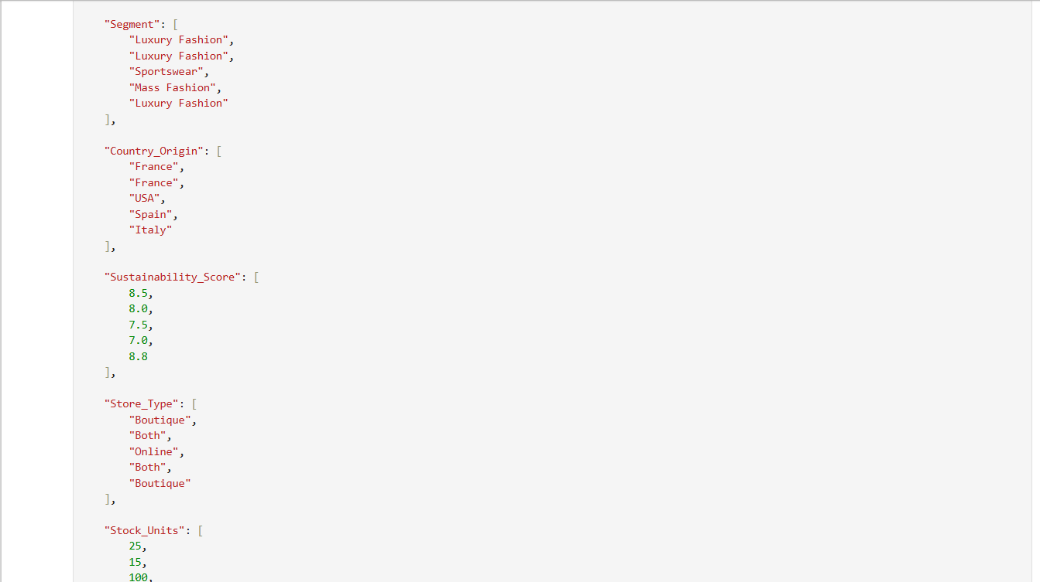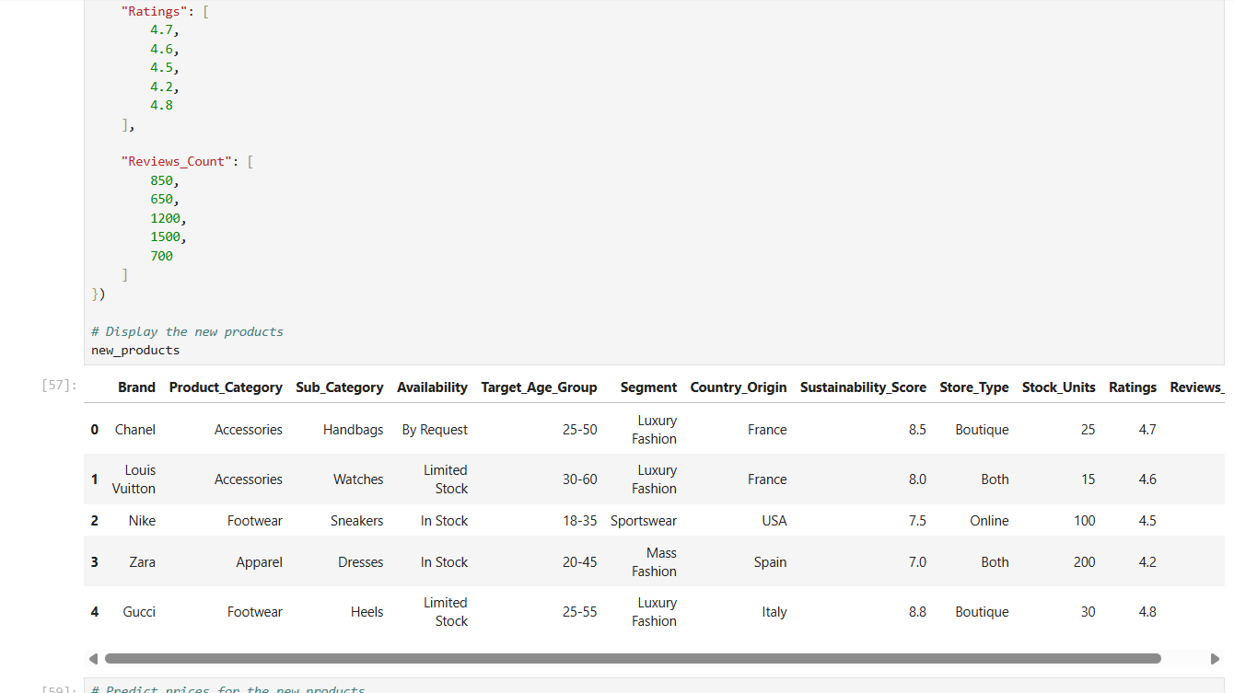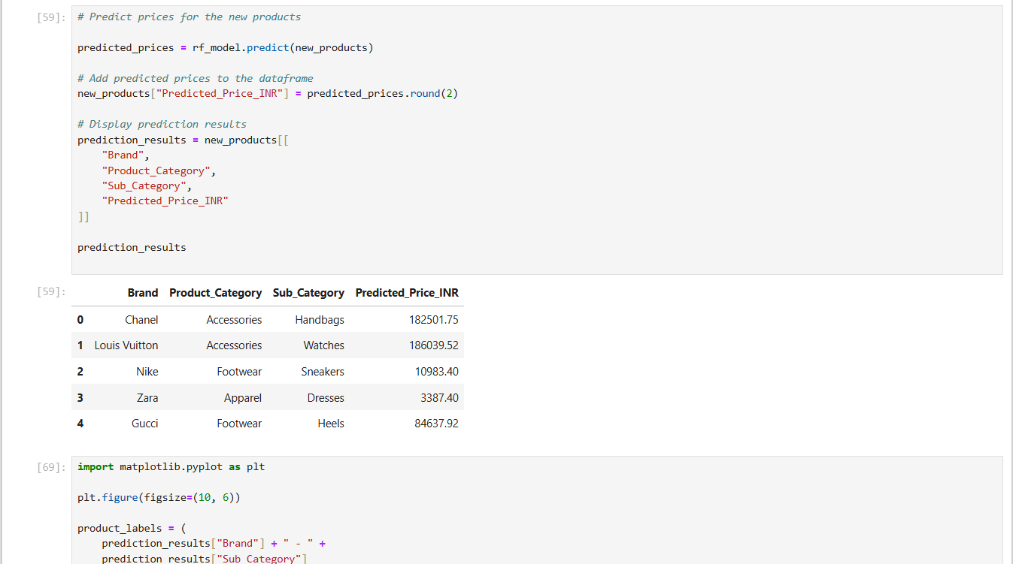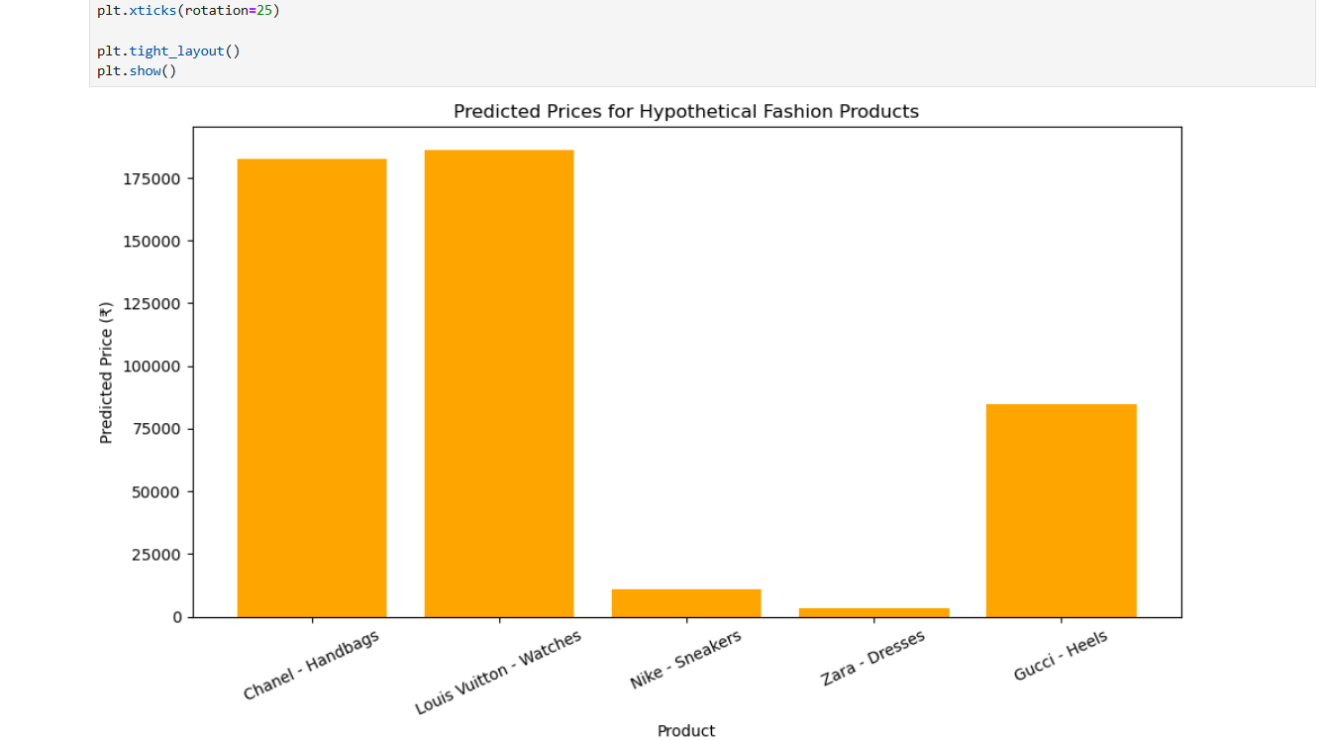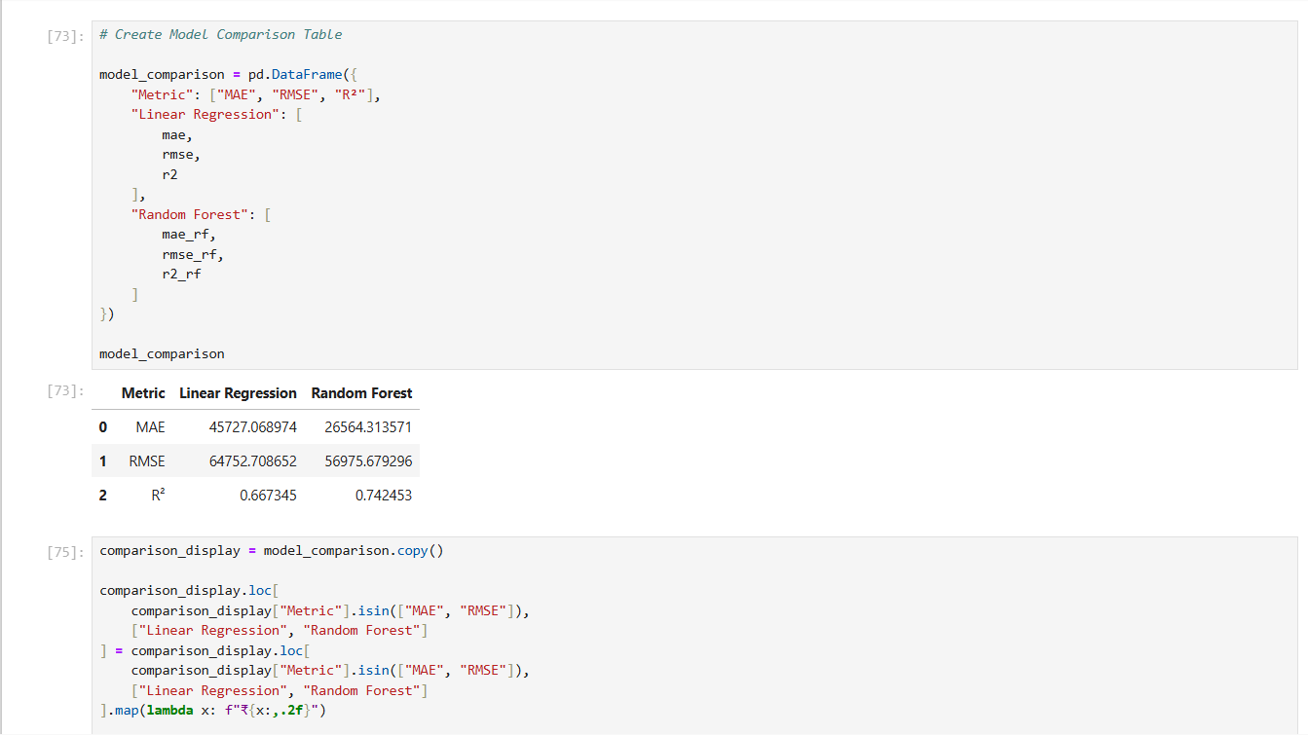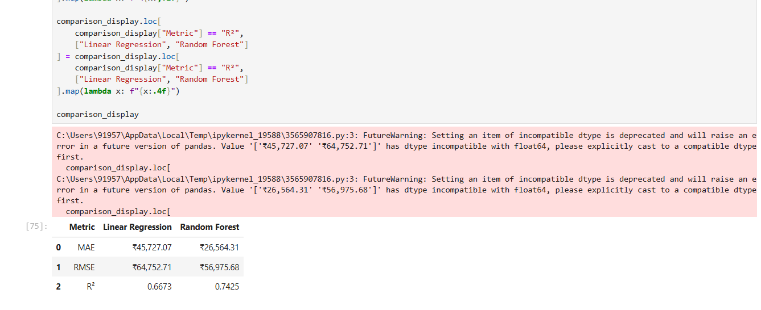

Model Evaluation

Metric | Linear Regression | Random Forest
MAE | ₹45,727.07 | ₹26,564.31
RMSE | ₹64,752.71 | ₹56,975.68
R² | 0.6673 | 0.7425

On the reported test dataset, Random Forest produced a lower MAE (Mean Absolute Error) and RMSE (Root Mean Squared error) and a higher R² than Linear Regression. The Task 4 report therefore used Random Forest as the final model for generating hypothetical product-price estimates.

Worked Example of Model Prediction

Actual Price | Predicted Price
₹1,990 | ₹2,654.350
₹1,80,000 | ₹2,27,529.900
₹45,000 | ₹9,740.975
₹14,500 | ₹20,450.900
₹3,990 | ₹5,314.100
₹2,490 | ₹1,869.650
₹1,20,000 | ₹1,86,219.775

The Random Forest model generated predicted prices for the test dataset. For example, one test observation had an actual price of ₹1,990, while the model predicted a price of approximately ₹2,654.35.
The absolute prediction error for this observation can be calculated as:

Absolute Error = |Actual Price − Predicted Price|
= |₹1,990 − ₹2,654.35|
= ₹664.35

Therefore, for this particular test observation, the model's prediction differed from the actual price by ₹664.35. This illustrates how the prediction error for an individual product can be calculated.
The overall MAE, RMSE and R² values reported above are calculated using all 35 observations in the test dataset, rather than this single example. The Random Forest model achieved an MAE of ₹26,564.31, RMSE of ₹56,975.68 and R² of 0.7425 on the reported test set.

Feature Importance
- Stock_Units: approximately 0.642773
- Ratings: approximately 0.154105
- Sub_Category_Handbags: approximately 0.041852
- Sustainability_Score and other availability/review-related variables also contributed to model predictions.
Feature importance indicates which variables were useful to the trained Random Forest model when making predictions. It does not establish that a feature directly causes a change in product price.

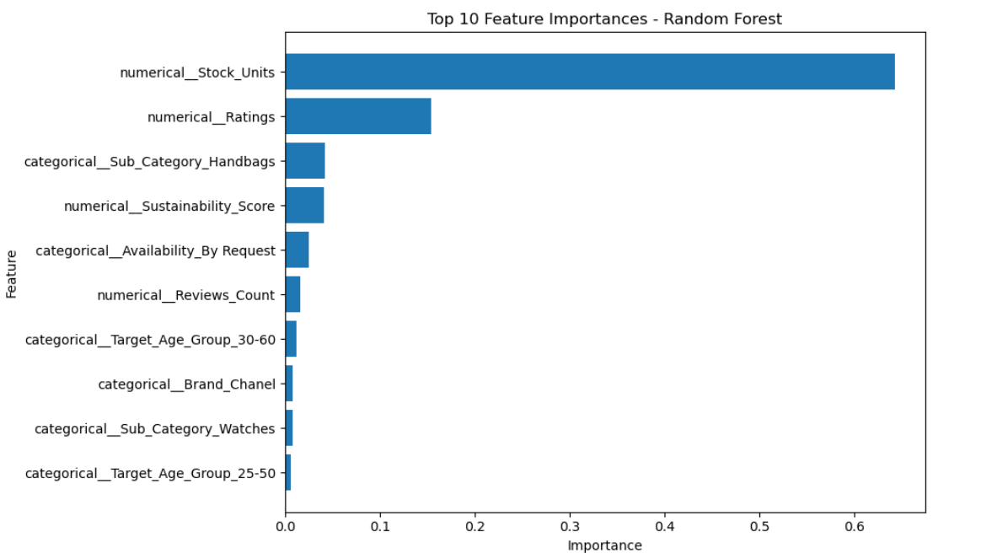

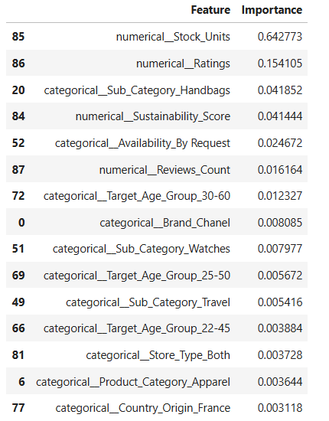

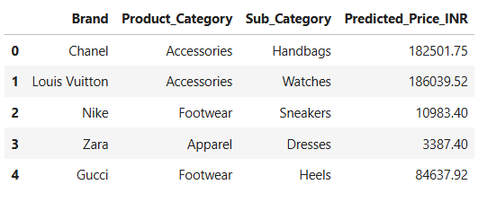
Predictive Modelling visualization

Interpretation and Limitations of Predictions
The model generated estimated prices for hypothetical products with different brand and category profiles. The reported examples showed higher estimated prices for the Chanel Handbag and Louis Vuitton Watch, lower estimates for the Zara Dress and Nike Sneakers, and an intermediate estimate for the Gucci Heels. These values are model-generated estimates and are not guaranteed future market prices.

- Strategic Recommendations
Task 5 translated the descriptive and predictive findings into five strategic areas for a hypothetical fashion brand. The recommendations are intended as practical guidelines and would require additional real-world business information before implementation.

Product Development
Recommendation: Develop and expand products by considering categories and sub-categories with stronger customer response while also monitoring inventory, sustainability and product characteristics.
Data-driven rationale: Stock_Units was the most influential model feature (approximately 0.642773), followed by Ratings (approximately 0.154105).

Proposed actions:
- Analyse ratings and reviews to identify product types receiving stronger customer response.
- Consider new designs, styles, sizes or variants within suitable categories.
- Review existing stock before increasing production.
- Consider sustainable materials, packaging and production methods where feasible.
- Regularly update product analysis using new sales, ratings, reviews and inventory data.

Anticipated outcome: The approach is intended to support more structured, data-informed decisions while remaining subject to additional business, market and operational information.

Pricing Strategy
Recommendation: Use a differentiated, data-supported pricing approach rather than applying one pricing method to every product.
Data-driven rationale: Random Forest reported R² = 0.7425, MAE = ₹26,564.31 and RMSE = ₹56,975.68 on the test set.
Proposed actions:
- Use the predictive model as supporting information for price-range estimation.
- Consider inventory levels when reviewing promotional pricing or discounts.
- Monitor ratings and reviews when reviewing product price positioning.
- Differentiate prices by product category, sub-category and other product characteristics.
- Review prices periodically using updated inventory, ratings, reviews and market data.

Anticipated outcome: The approach is intended to support more structured, data-informed decisions while remaining subject to additional business, market and operational information.

Target Demographics
Recommendation: Use Target_Age_Group and Segment to organize product planning and marketing activities around different customer groups.
Data-driven rationale: Target_Age_Group and Segment were included as model inputs and provide demographic/market-positioning information.
Proposed actions:
- Identify major customer groups represented in the market.
- Develop segment-specific product styles, sizes, colours and variants.
- Use communication relevant to each target demographic.
- Align price ranges and product characteristics with target segments.
- Monitor ratings and reviews to understand customer response.

Anticipated outcome: The approach is intended to support more structured, data-informed decisions while remaining subject to additional business, market and operational information.

Inventory Management
Recommendation: Continuously monitor stock levels and use inventory information to support production, pricing and promotional decisions.
Data-driven rationale: Stock_Units was the most influential Random Forest feature at approximately 0.642773; Ratings was second at approximately 0.154105.
Proposed actions:
- Maintain updated stock records and identify unusually high or low inventory.
- Consider promotions or targeted marketing for products with consistently high stock.
- Review timely replenishment for products with stronger customer response and lower availability.
- Connect stock information with pricing reviews.
- Use historical stock, ratings, reviews and product performance for future planning.

Anticipated outcome: The approach is intended to support more structured, data-informed decisions while remaining subject to additional business, market and operational information.

Sustainability Strategy
Recommendation: Integrate sustainability into product development, sourcing and positioning alongside price, customer response, category and inventory considerations.
Data-driven rationale: Sustainability_Score was included as a numerical model feature and was considered alongside other product and market characteristics.
Proposed actions:
- Consider sustainable materials and production methods where feasible.
- Include sustainability measures when evaluating new product lines.
- Use inventory and demand information to reduce unnecessary production and waste.
- Communicate sustainability information clearly and factually.
- Track sustainability-related measures over time.

Anticipated outcome: The approach is intended to support more structured, data-informed decisions while remaining subject to additional business, market and operational information.

Recommendation | Action Plan | Success Metric
Pricing Strategy | Use the Random Forest model as a supporting tool along with competitor prices, brand positioning and product characteristics when reviewing prices. | MAE/RMSE of future predictions and difference between predicted and actual prices
Inventory Management | Monitor stock levels together with ratings and review activity to identify products that may require replenishment or closer monitoring. | Stock turnover, stock-out frequency and excess inventory
Product Development | Identify categories and sub-categories showing strong ratings and review activity and consider them for further product development. | Average rating, review growth and product demand/sales where available
Sustainability | Track sustainability scores and encourage products with stronger sustainability characteristics. | Average sustainability score and percentage of products meeting the selected sustainability criteria
Customer Targeting | Use target age group and customer segment information to tailor product positioning and marketing. | Segment engagement, ratings and conversion/sales data where available

- Integrated Findings and Business Implications
Across the five tasks, the analysis shows how descriptive and predictive methods can be connected into a single decision-support workflow. The market research established differences in brand segment and observed price levels. Data preparation improved consistency. Power BI then identified patterns in pricing, sustainability, product representation and review engagement. Predictive modelling added a price-estimation component, while Task 5 (Strategic Recommendations) converted the findings into strategic guidelines.

Area | Integrated finding | Potential use in planning
Pricing | Average prices differed substantially across the selected brands; Random Forest used multiple product and market variables for price estimation. | Use model estimates with costs, competitor prices, demand, positioning and margins.
Customer response | Ratings were high across brands; Apparel had the highest reported review volume. | Monitor ratings and review volume by category and product.
Inventory | Stock_Units was the most influential feature in the Random Forest model. | Use stock monitoring to support replenishment, promotions and product planning.
Product mix | Accessories had the largest product count; Luxury Fashion was the largest segment in the sample. | Compare assortment size with customer engagement before expanding ranges.
Sustainability | Nike and Zara had the highest reported average sustainability scores in the analysed dataset. | Include sustainability alongside other product and business measures.
Targeting | Target_Age_Group and Segment were included as modelling features and in strategic recommendations. | Use segment information when planning products and marketing.

The findings should be considered as the evidence from the analysed dataset rather than exact measures of the entire fashion market. Actual business decisions would require sales performance, production costs, competitor prices, customer behaviour , seasonal demand and current market conditions.

- Limitations
- The original Task 2 submission required a dataset update because Zara records were not included. This was corrected before Task 3, and the final analytical dataset used in this report contains 173 product records.
- For consistency, the final report uses the corrected 173-record dataset for all analysis, predictive modelling and recommendations presented after the Task 2 dataset update.
- Product popularity in Task 3 was represented primarily through product count rather than actual sales volume.
- Customer preference was inferred mainly from ratings and review volume; direct purchase behaviour was not available.
- Sustainability score was treated as a dataset-based indicator.
- The dashboard results describe the selected sample and should not be interpreted as exact real-world market share.
- The predictive model did not include factors such as discounts, seasonal demand, competitor pricing, promotions or economic conditions.
- The model estimates product prices based on product characteristics; it does not perform time-series forecasting.
- Feature-importance values show model usefulness for prediction and do not prove direct cause-and-effect relationships.
- Hypothetical product predictions are model estimates rather than guaranteed future market prices.

- Conclusion
The Week 6 Task report consolidates the complete fashion market research workflow carried out during the internship tasks. The study examined Nike, Chanel, Louis Vuitton, Zara and Gucci using market research, data cleaning, Power BI analysis, predictive modelling and strategic recommendation development.
The descriptive analysis identified substantial differences in average price levels across the selected brands, while customer ratings remained relatively high across the dataset. Luxury Fashion was the largest represented segment, Accessories was the largest category by product count, and Apparel produced the highest review-based customer engagement. Sustainability also provided a point of differentiation within the analysed sample.
The predictive modelling stage demonstrated how regression techniques can be applied to fashion pricing. Linear Regression provided a baseline, while Random Forest Regression produced the reported test-set metrics of MAE ₹26,564.31, RMSE ₹56,975.68 and R² 0.7425. Stock_Units and Ratings were among the most influential features in the trained model.
Finally, the strategic recommendations connected these findings to product development, pricing, target demographics, inventory management and sustainability. Overall, the work demonstrates a structured data-analytics process in which market information is transformed into a clean dataset, analysed through visualization, extended through predictive modelling and translated into practical decision-support guidance. The recommendations remain subject to further validation using larger datasets and additional real-world business information.

12. References and Sources
The following sources were used for Week 1 market research report:
- Nike India – https://www.nike.com/in/
- Chanel India – https://www.chanel.com/in/
- Louis Vuitton India – https://in.louisvuitton.com/
- LVMH – https://www.lvmh.com/
- Gucci India – https://www.gucci.com/in/en/
- Kering – https://www.kering.com/
- Zara India – https://www.zara.com/in/
- Inditex – https://www.inditex.com/
- Nike official Instagram – https://www.instagram.com/nike/
- Chanel official Instagram – https://www.instagram.com/chanelofficial/
- Louis Vuitton official Instagram – https://www.instagram.com/louisvuitton/
- Gucci official Instagram – https://www.instagram.com/gucci/
- Zara official Instagram – https://www.instagram.com/zara/

